**STOCK PORTFOLIO MANAGEMENT SYSTEM**

**LOW LEVEL DESIGN**

**Zero Level Flow Diagram of Stock Portfolio:**

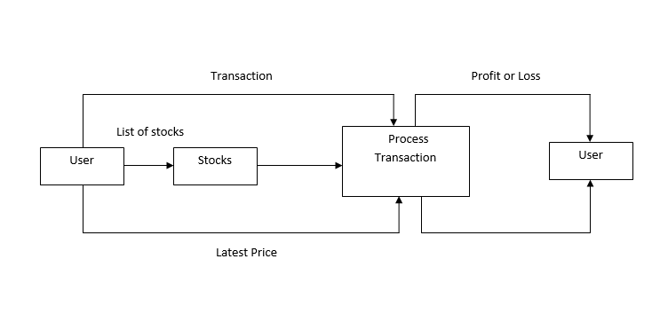

**Stock Portfolio Process Overview:**

* + - * The purpose of this project is to implement a stock portfolio management application that will allow to analyse a collection of investments like stocks.
      * This project is to create a portfolio for each user and they can add transaction and update portfolio according. This project can display report of profit and loss for user

**Procedure flow:**

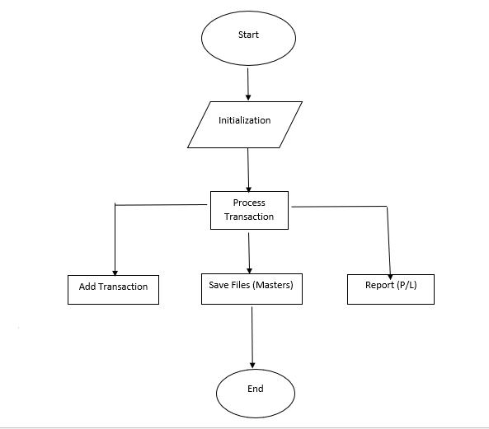

**Initialization:**

Load the stock name from stock.ini file and previous details from transaction.csv file**.**

**Add Transaction:**

Add the latest price of stock and update transaction records.

**Save Files (Masters):**

After Update save the existing file.

**Report (Profit/Loss):**

Calculate the average price of stock and display the profit or loss.

**First Level DFD**

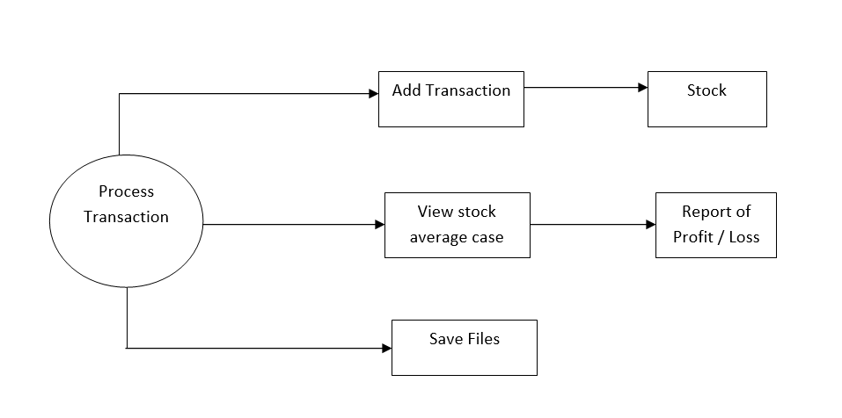

**Add Transaction:**

Add the latest price of stock and update transaction records.

**Stock:**

Update and save the stock.ini file and transaction.csv file.

**View stock average case:**

If you want to see profit or loss then we can find average of stock.

**Report of Profit / Loss:**

Calculate the average price of stock and display the profit or loss.

**Save Files:**

After Update save the existing file.